**SDM End Module Answers**

Q1)

AWS EC2 instance created

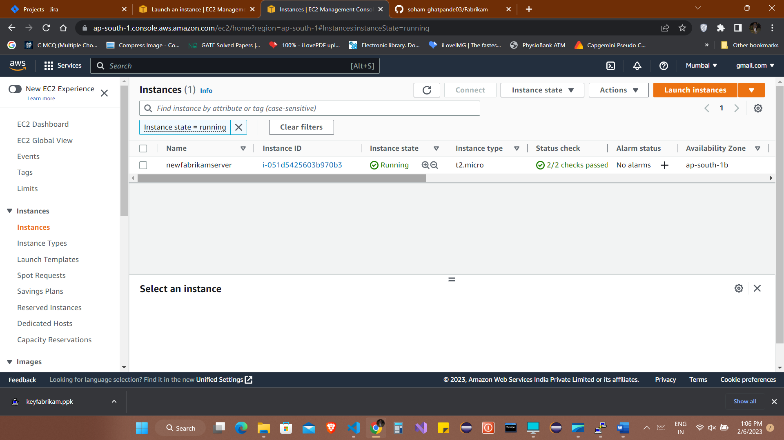

Q2)

Docker installed on Ubuntu OS on EC2 server

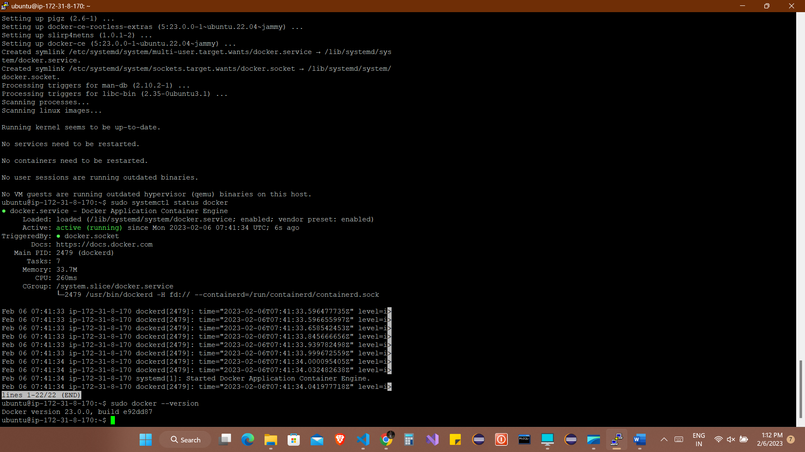

Q3)

Fabrikam repository created on Github

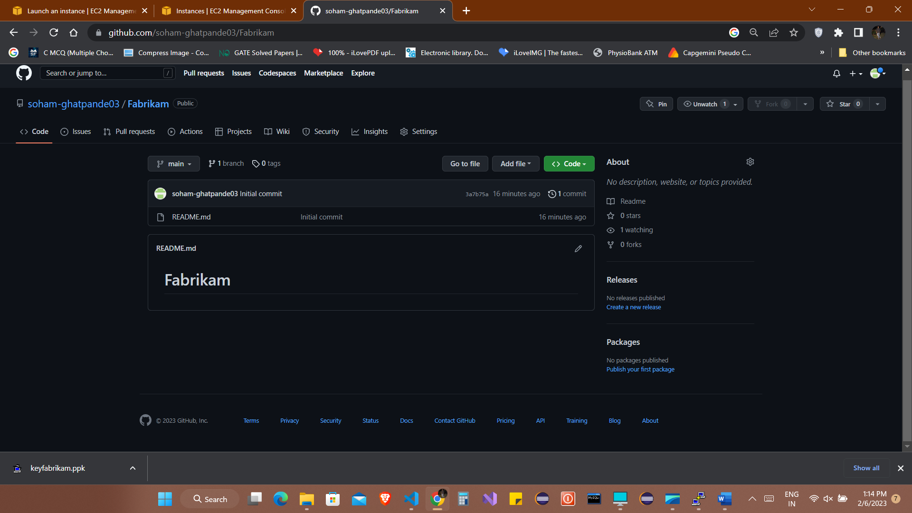

Q4)

Local repository created on Developer machine **git clone** [**https://github.com/soham-ghatpande03/Fabrikam.git**](https://github.com/soham-ghatpande03/Fabrikam.git)in cmd

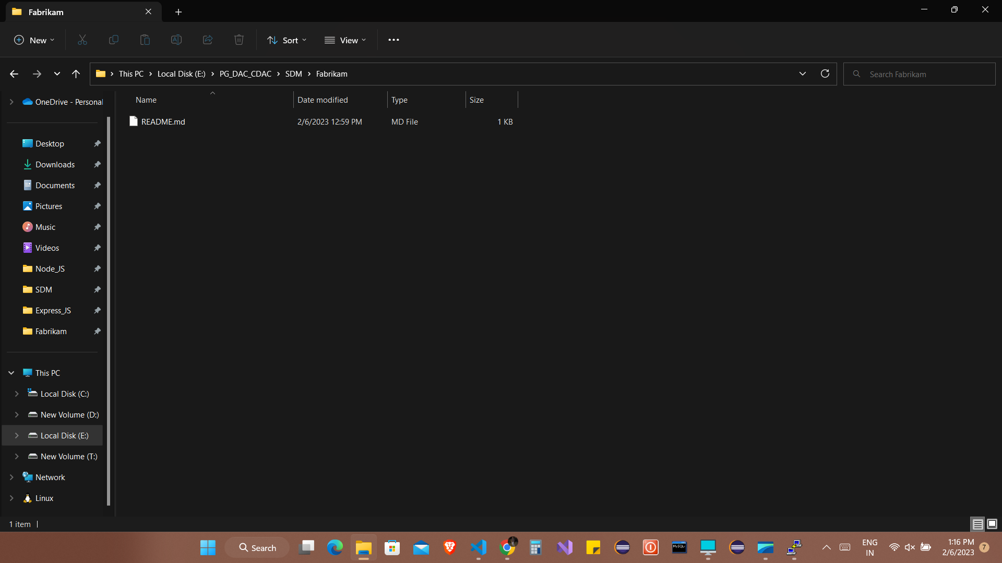

Q5)

Package.json file added using command **npm init** and added the .js file with other required files.

Installed all the express modules using **npm install express**

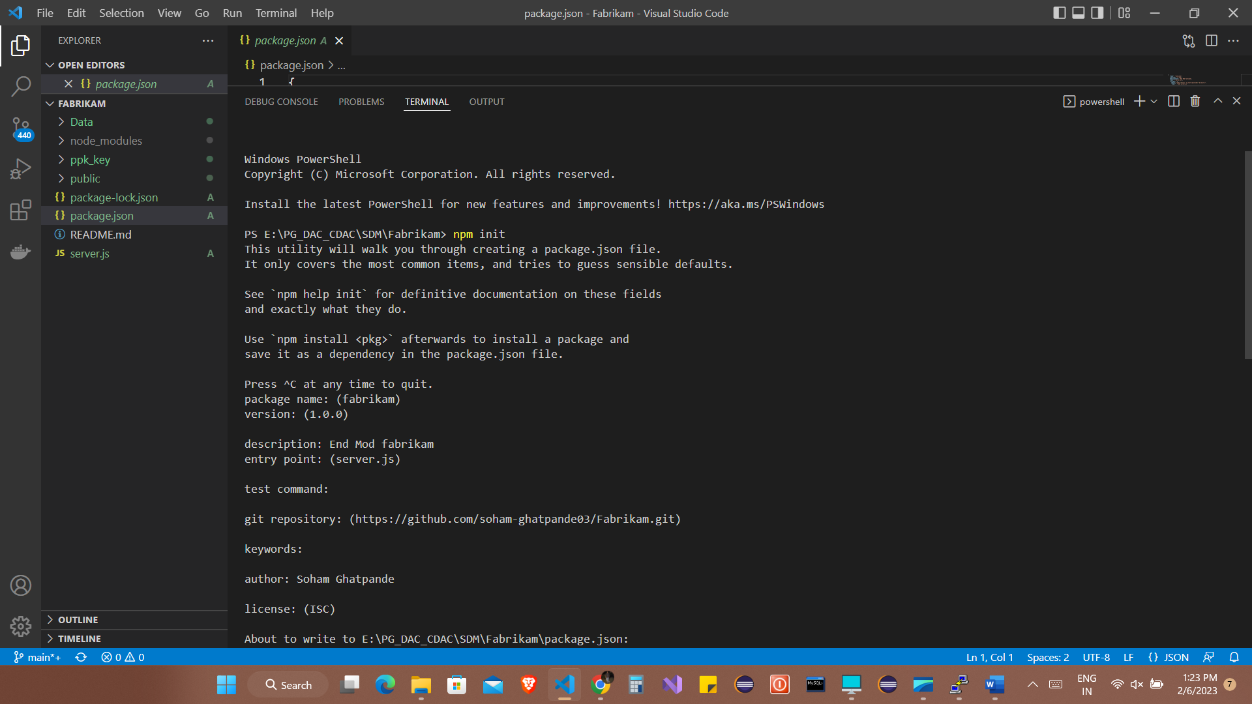

Q6)

Adding the Dockerfile

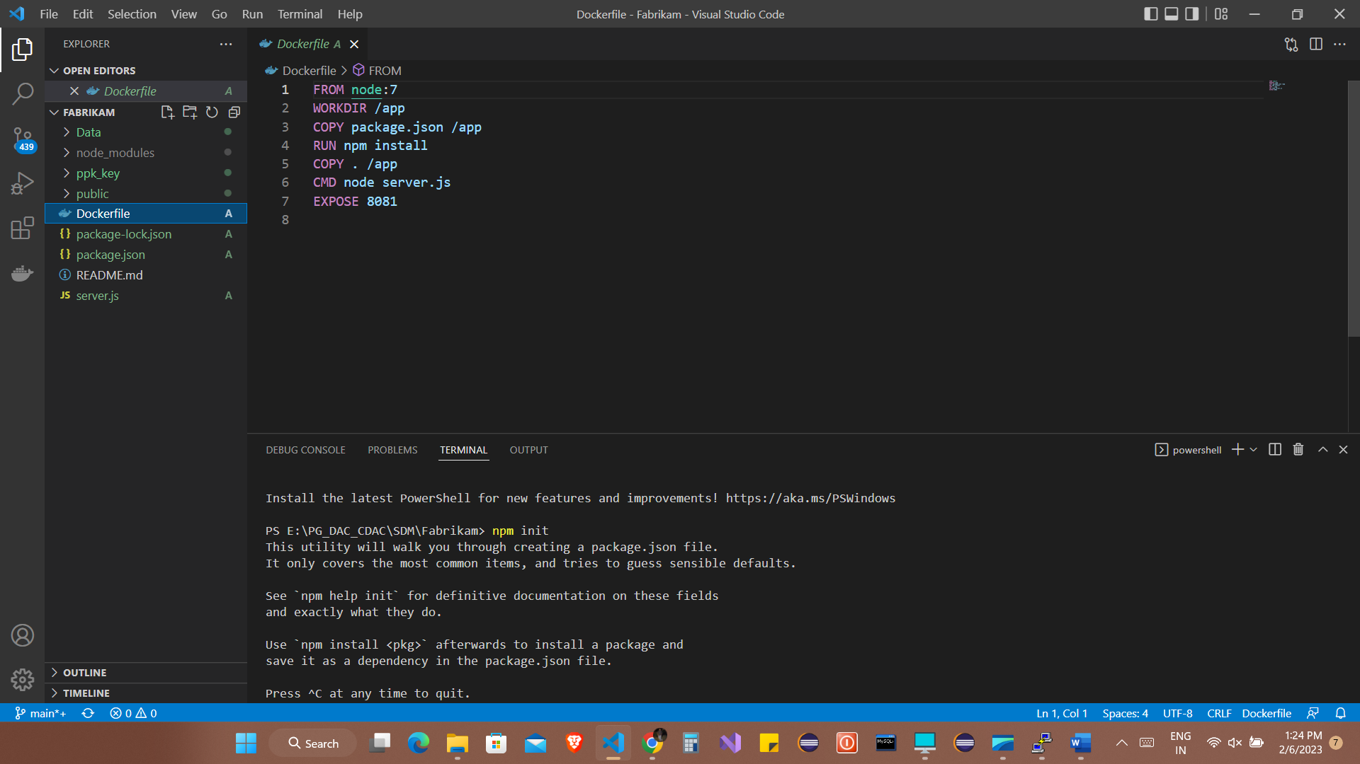

Q7)

Commited data using commands

**git add .**

**git commit -m “message”**

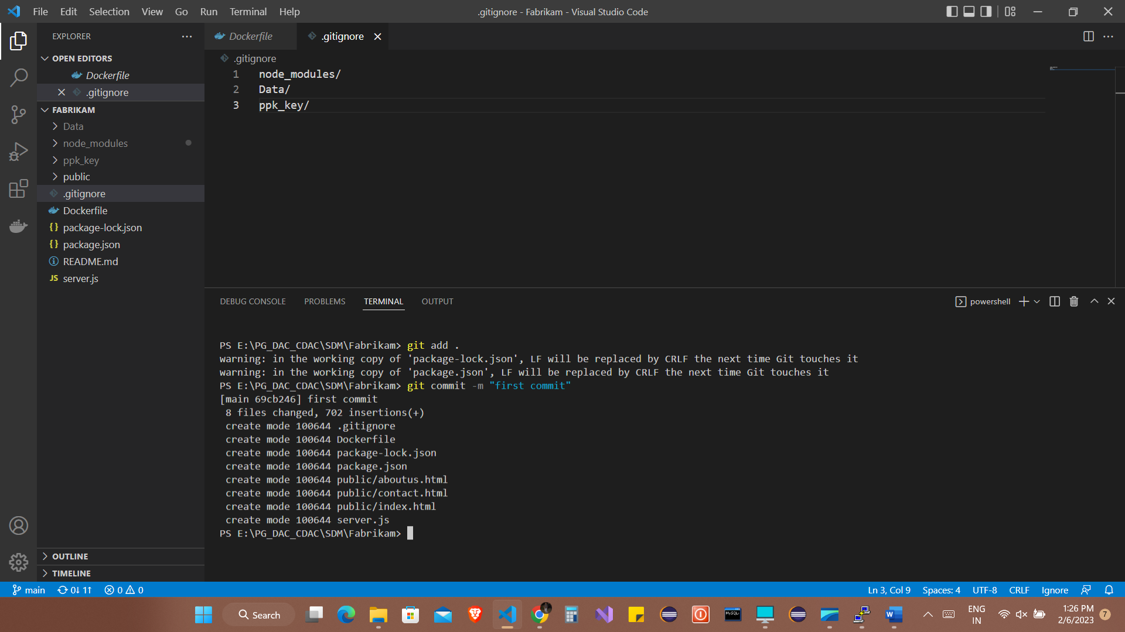

Q8)

Pushed the data to git repository using command **git push**

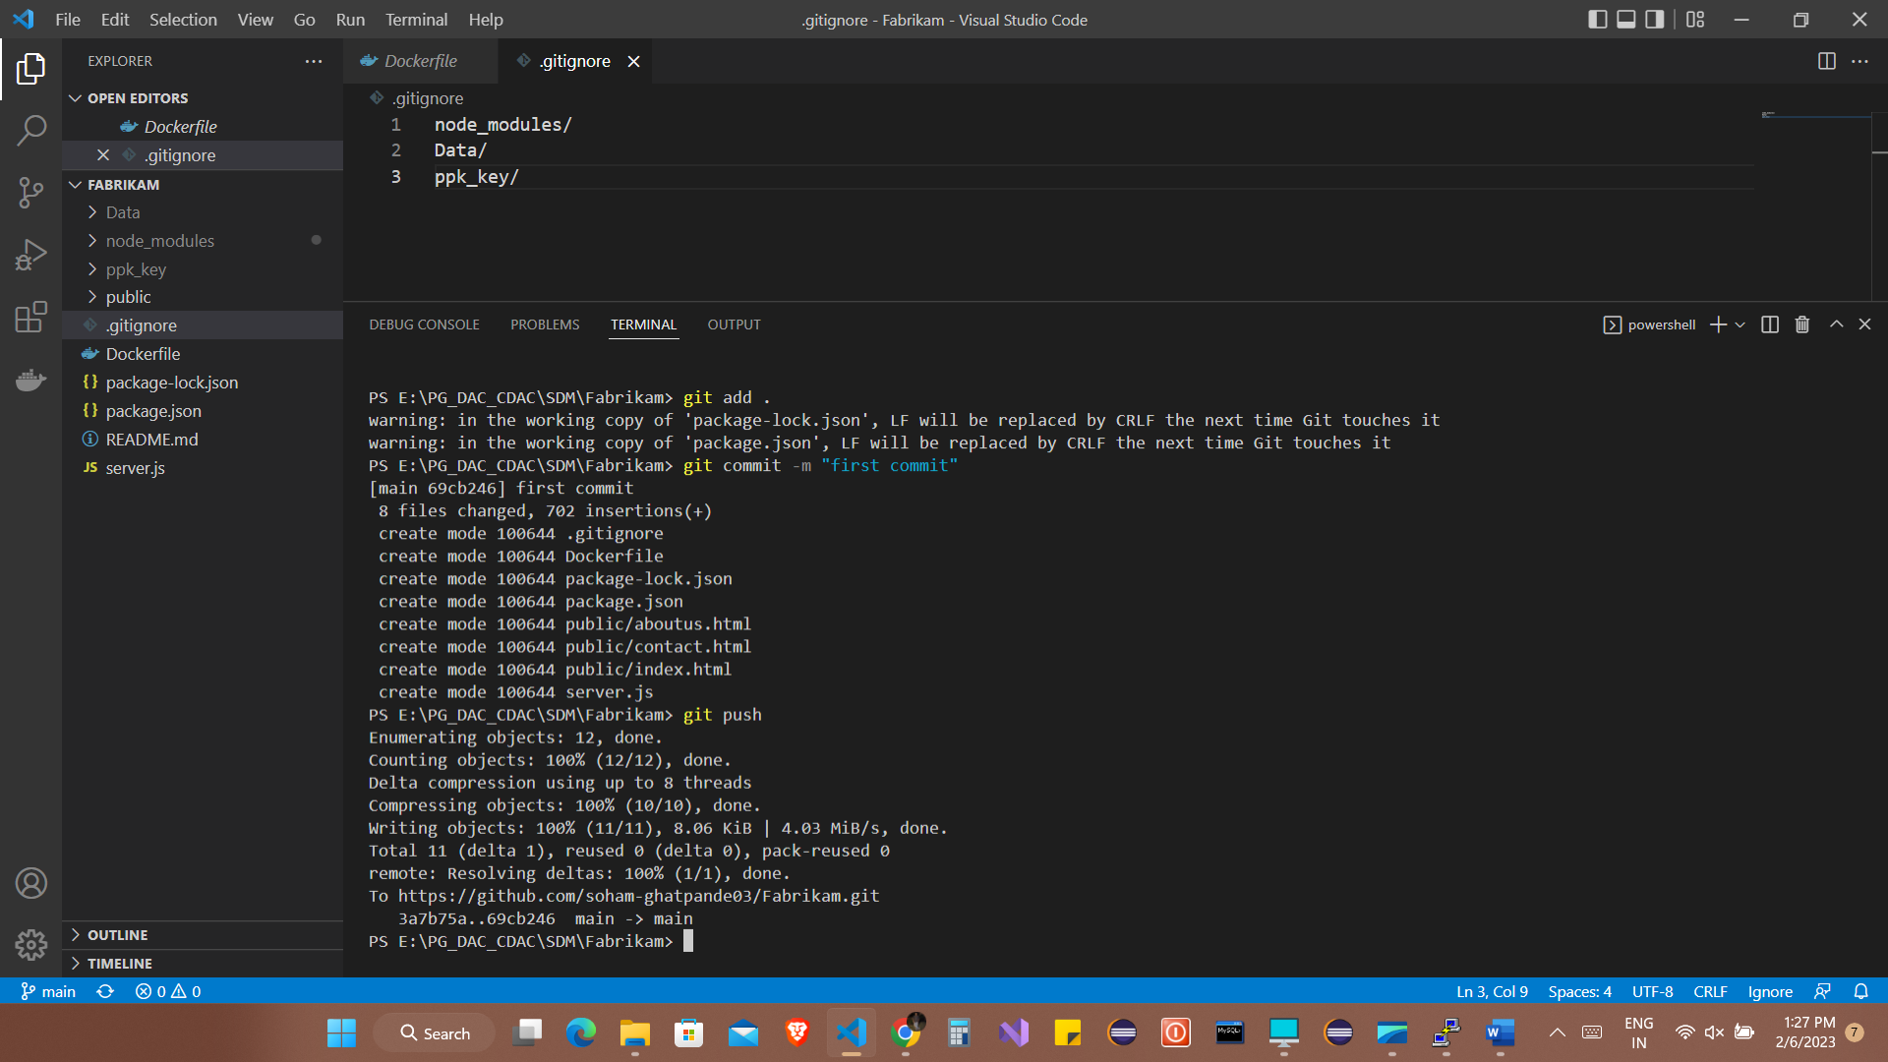

Q9)

Git installed on EC2 server (using ubuntu hence git already installed)

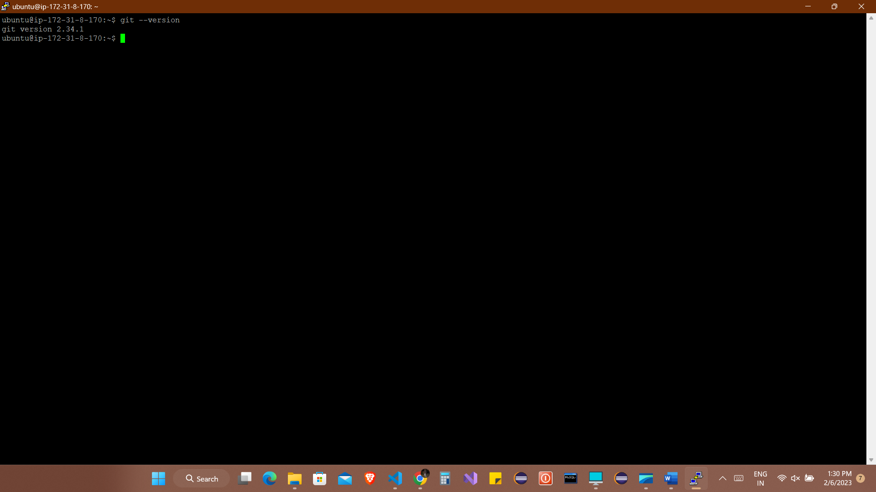

Q10)

Cloned repository on EC2 server using command **git clone https://github.com/soham-ghatpande03/Fabrikam.git**

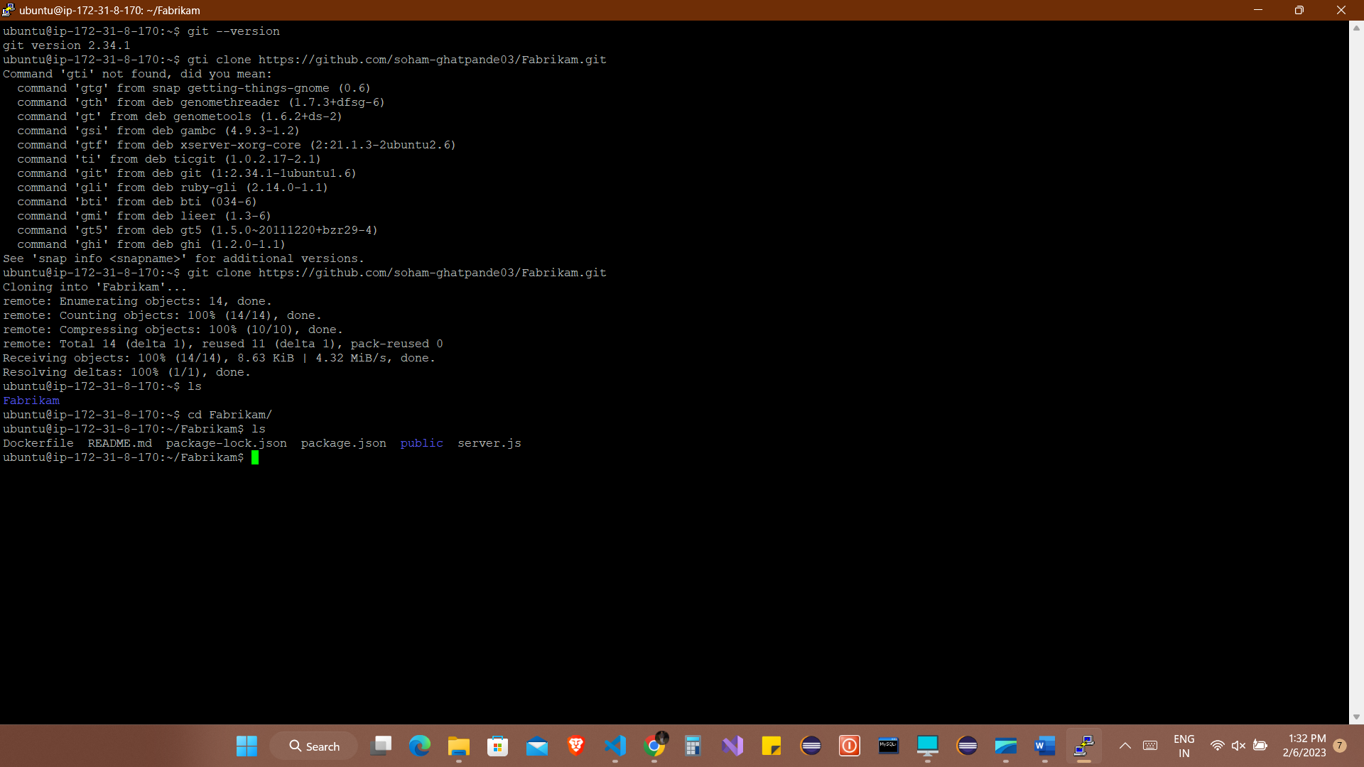

Q11)

Docker image creation using **sudo docker built -t imagename** .

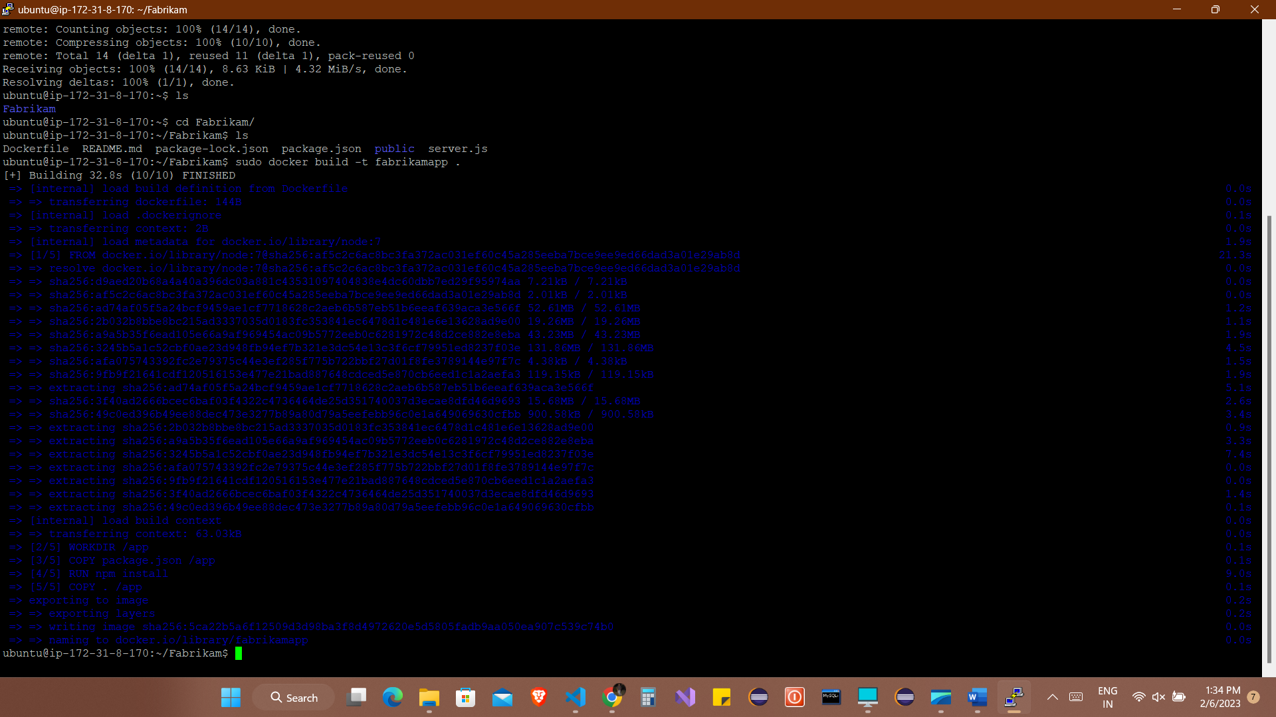

Q12)

List of container images using command **sudo docker images**

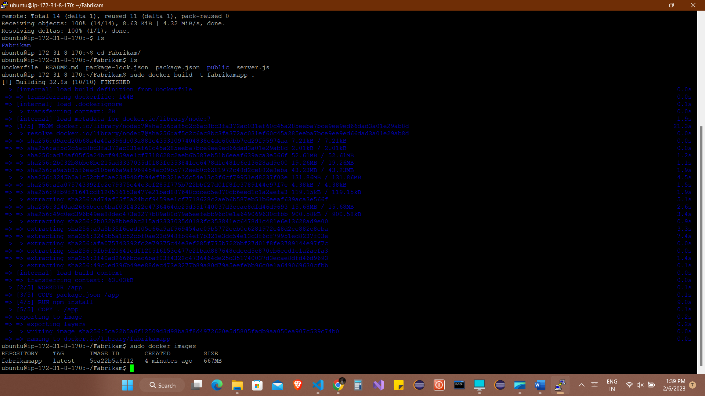

Q13)

Running the image using command **sudo docker run -d -p 8001:8081 fabrikamapp**

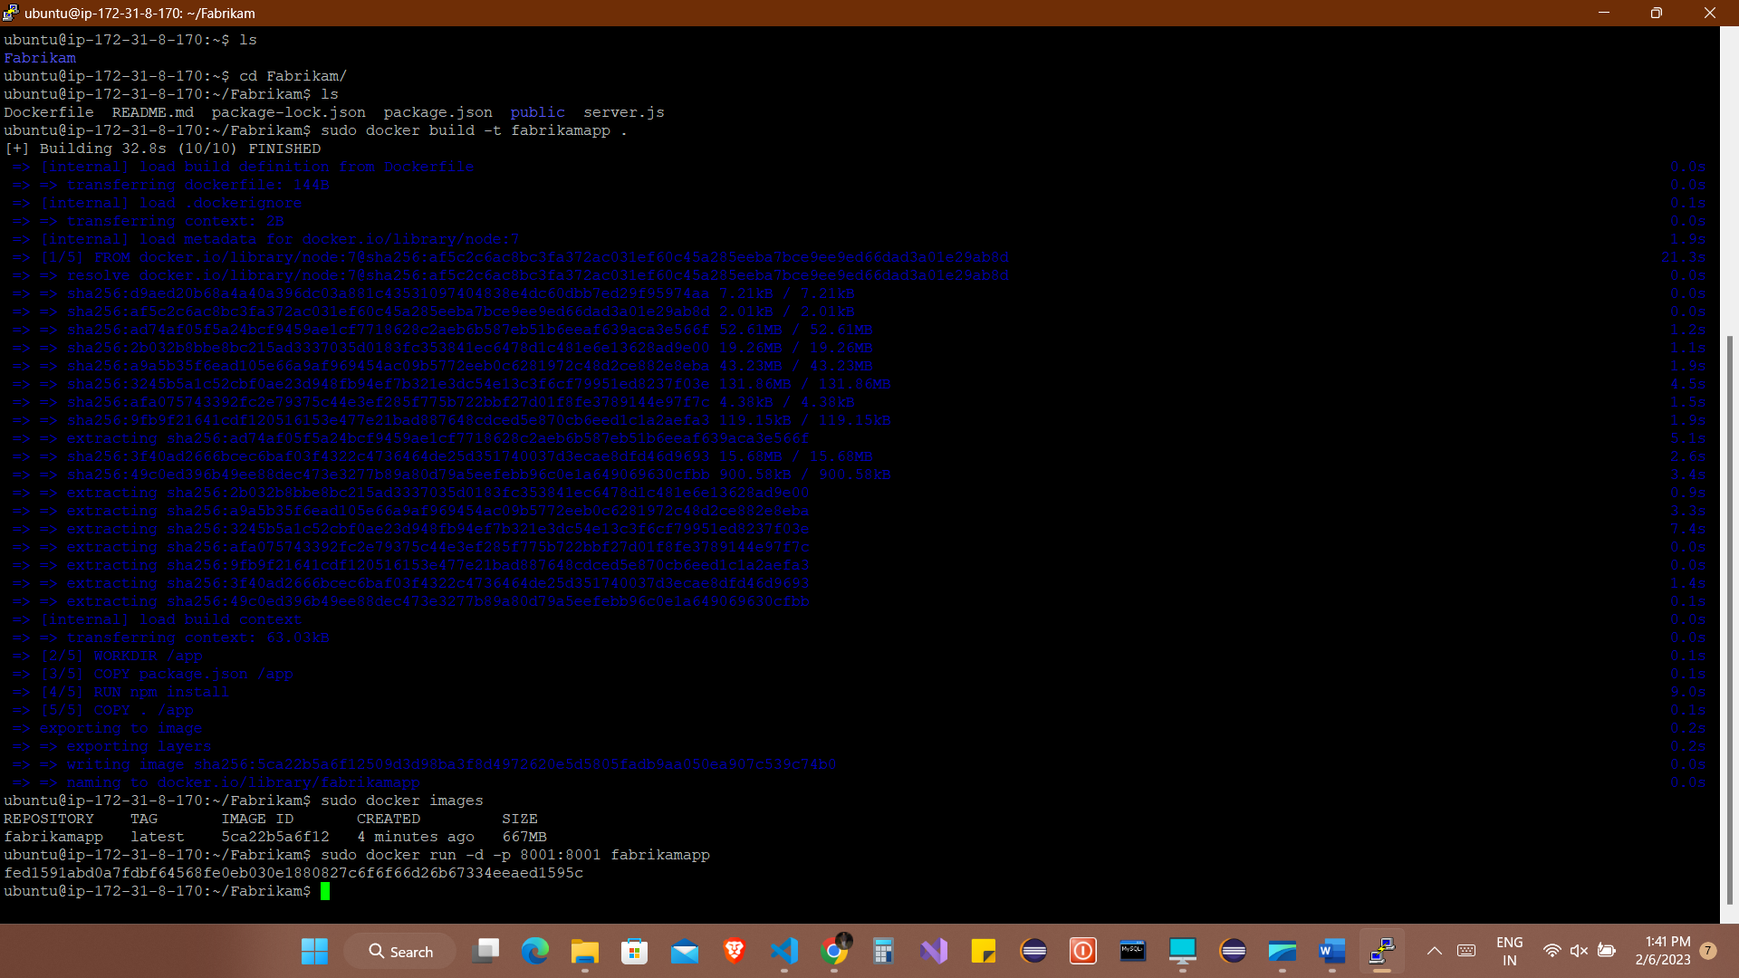

Q14)

List of images running using command **sudo docker ps**

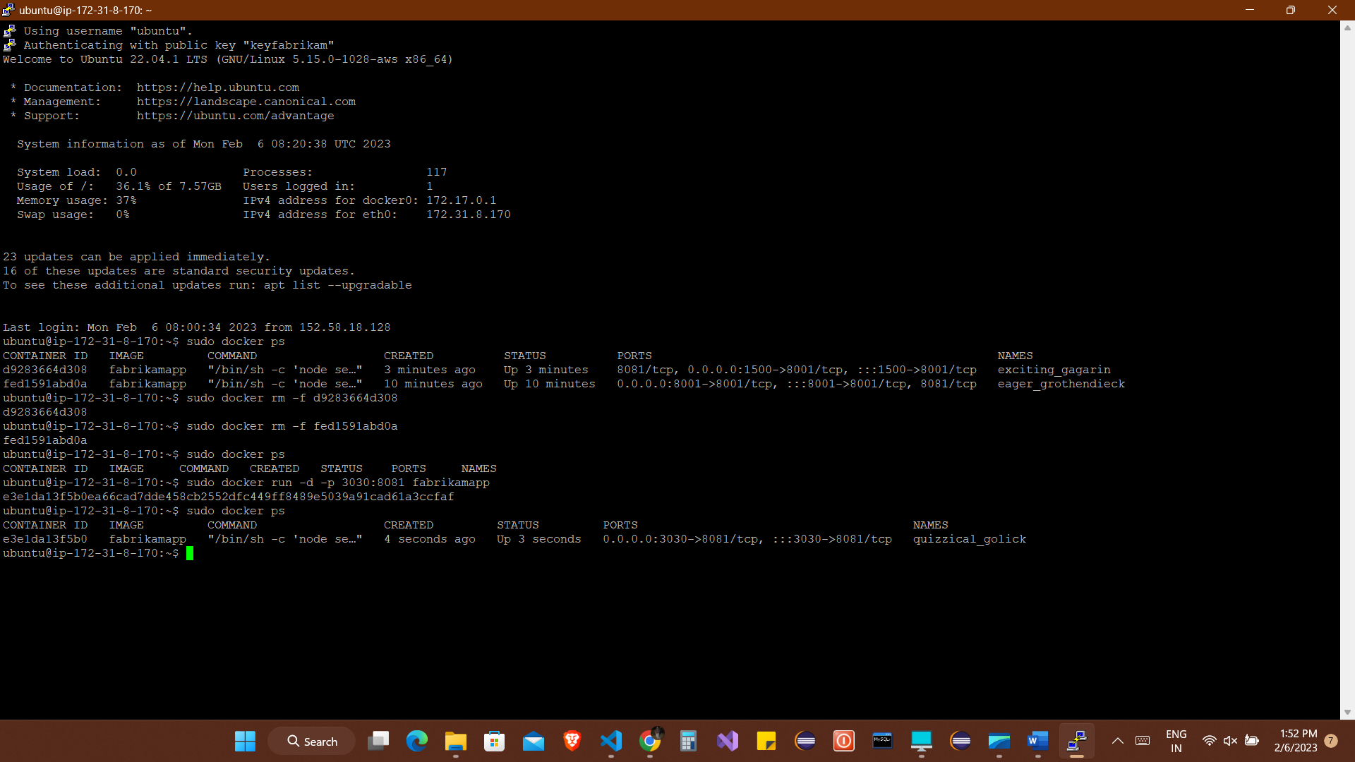

Q15)

Adding the inbound rules on EC2 instance in the security groups setting

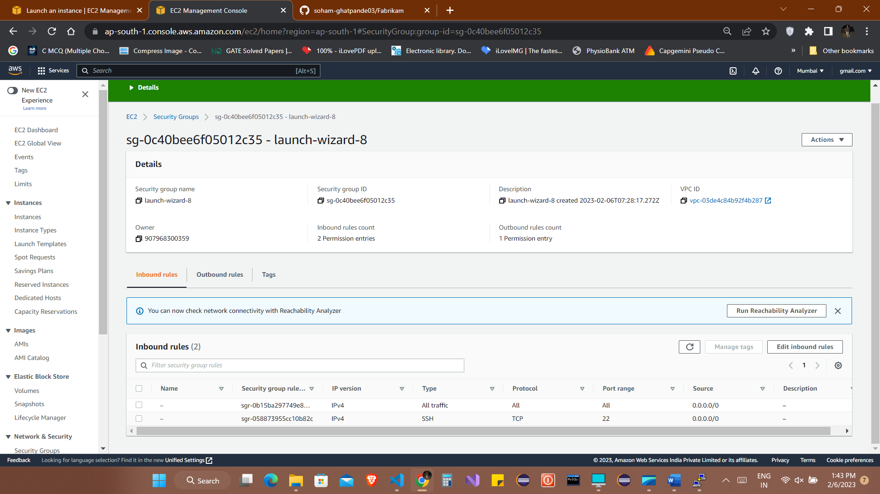

Q16)

Running the file on the local IP address and the assigned port

**http://65.0.176.76:3030/index.html**

